Pylint testing:

I ran pylint 2 times, both getting a perfect score of 10/10.00. However, I am not sure if my score really is perfect, as pylint appears to have only tested the Python file, and not the .html templates.

Test Cases:

|  |  |  |  |  |
| --- | --- | --- | --- | --- |
| Test Case: | Actions: | Expected Output: | Actual Output: | Pass? |
|  | Launching the app. | Command Prompt informs user of app running on specified localhost.  Upon going to specified localhost, app homepage is displayed. | Command Prompt informs user of app running on specified localhost.  Upon going to specified localhost, app homepage is displayed. | Yes |
|  | Launching the app, clicking on the Queen Mary link. | Command Prompt informs user of app running on specified localhost. Upon going to specified localhost, and clicking on Queen Mary link, app displays Queen Mary information. | Command Prompt informs user of app running on specified localhost. Upon going to specified localhost, and clicking on Queen Mary link, app displays Queen Mary information. | Yes |
|  | Launching the app, clicking on the Queen Elizabeth link. | Command Prompt informs user of app running on specified localhost. Upon going to specified localhost, and clicking on Queen Elizabeth link, app displays Queen Elizabeth information. | Command Prompt informs user of app running on specified localhost. Upon going to specified localhost, and clicking on Queen Elizabeth link, app displays Queen Elizabeth information. | Yes |
|  | Launching app, clicking on first “Further Reading” link. | Upon clicking on the link, user is redirected to the official webpage for the Queen Mary hotel. | Upon clicking on the link, user is redirected to the official webpage for the Queen Mary hotel. | Yes |
|  | Launching app, clicking on second “Further Reading” link. | Upon clicking on the link, user is redirected to an Owlcation article about the Queen Elizabeth. | Upon clicking on the link, user is redirected to an Owlcation article about the Queen Elizabeth. | Yes |
|  | Launching app, clicking on third “Further Reading” link. | Upon clicking on the link, user is redirected to the Facebook page of the R.M.S. Queen Elizabeth Historical Society. | Upon clicking on the link, user is redirected to the Facebook page of the R.M.S. Queen Elizabeth Historical Society. | Yes |

Test Case 1 Screenshots:

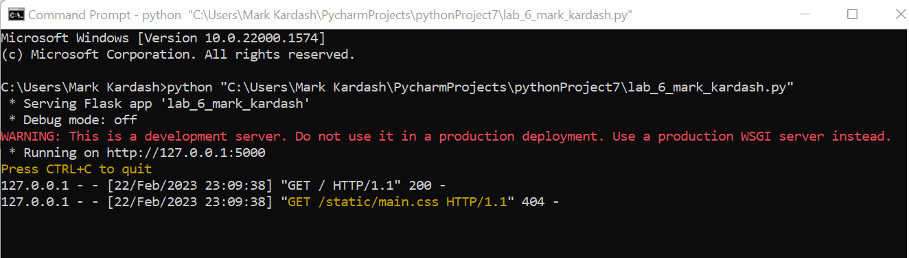

Test Case 2 Screenshots:

Test Case 3 Screenshots:

Test Case 4 Screenshots:

Test Case 5 Screenshots:

Test Case 6 Screenshots:

Conclusion:

I don’t have much to say here besides the fact that it all worked perfectly. The only complaint I would have for my website is that it doesn’t have any images, but, since that was not required, and I was already behind schedule, I decided not to include any. I am also unsure if the third additional resource, the R.M.S. Queen Elizabeth Historical Society, is an actual organization or more of a fan page. I looked them up, and apparently they own a “R.M.S. Queen Elizabeth Museum” somewhere, although, as an avid ocean liner enthusiast, I must admit I have never heard of them before. In any case, I believe I demonstrated linking skills on a good level, regardless of the quality of the source.